LAB EXAM-2
HTNO:2403a51285
BATCH-12

B)1-PROMPT:

Implement a Python function to calculate ride fares for a real estate listings platform.
Each ride is a dictionary with 'time' in 'HH:MM' format (24-hour) and 'km' as a float.
Use the formula: fare = km * base_per_km * surgeMultiplier
- base_per_km = 14.0
- surgeMultiplier = 2.0 applies strictly after 18:00 (i.e., > 18:00).
- Exactly 18:00 is non-surge.
Requirements:
- Parse 'HH:MM' correctly.
- Apply surge condition precisely.
- Round each fare to 2 decimal places.
- Do not mutate the input list.
- No external libraries

CODE:
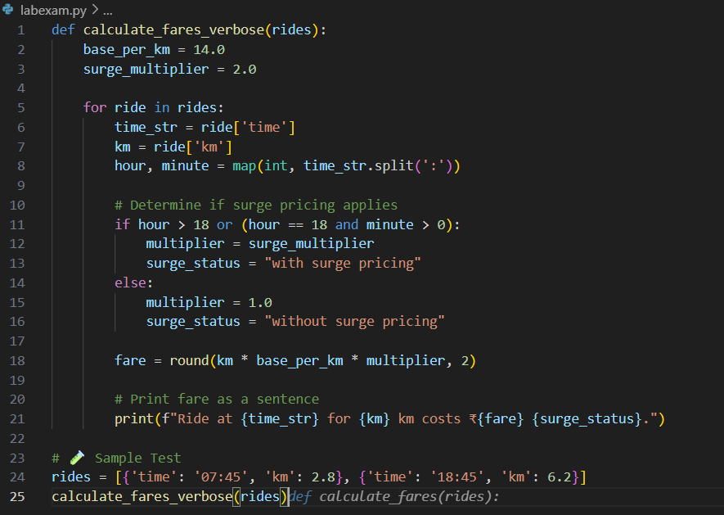

OUTPUT:

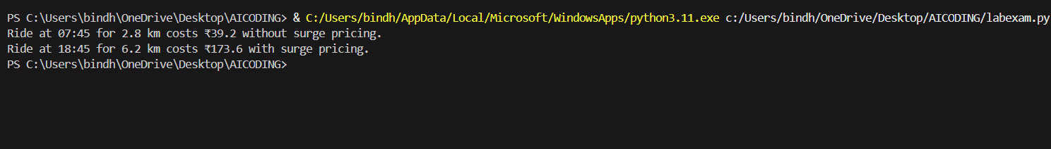

B)2-PROMPT:
def rolling_mean(xs, w):
sums = []
for i in range(len(xs)-w):
window = xs[i:i+w]
sums.append(sum(window)/w)
return sums

Add a failing test to demonstrate the bug.
- Propose the minimal fix to include all valid windows.
- Guard against invalid w values (≤ 0 or > len(xs)).
- Verify the fix using this sample input: xs = [4, 5, 7, 10], w = 2

CODE:

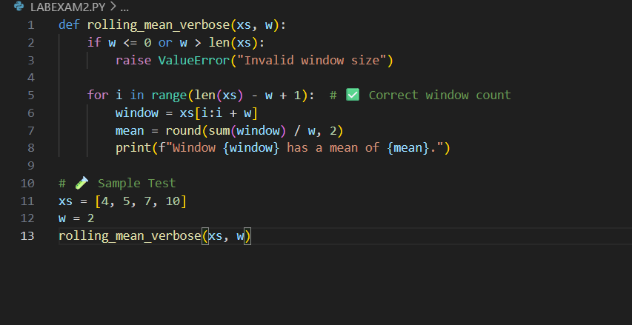

OUTPUT:

